* A web service is a piece of software that can be called over internet.
* There are two kinds of Web Services:

1. SOAP Services –xml
2. RESTFul Services –xml and JSON.

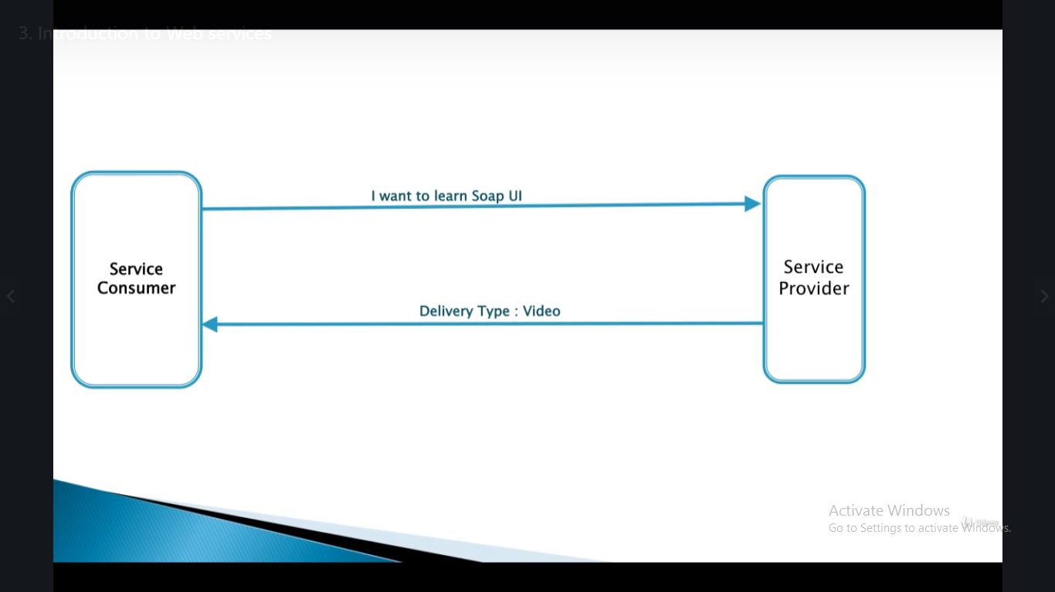

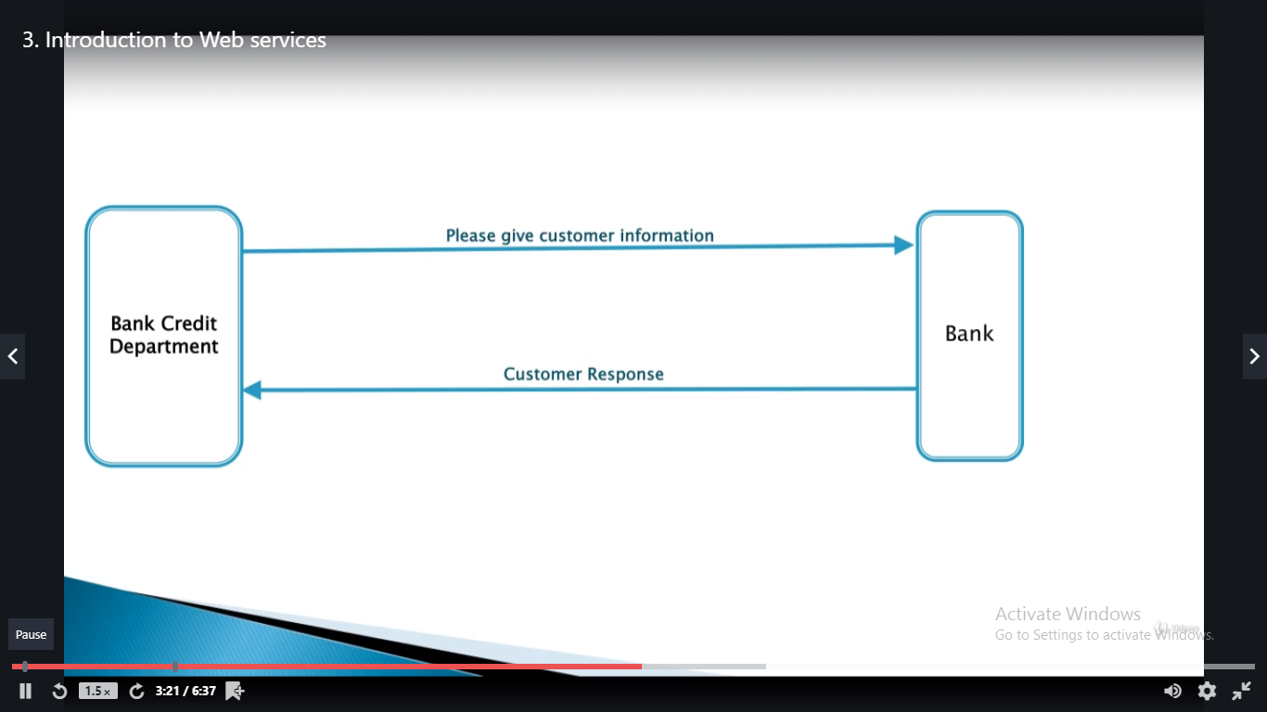

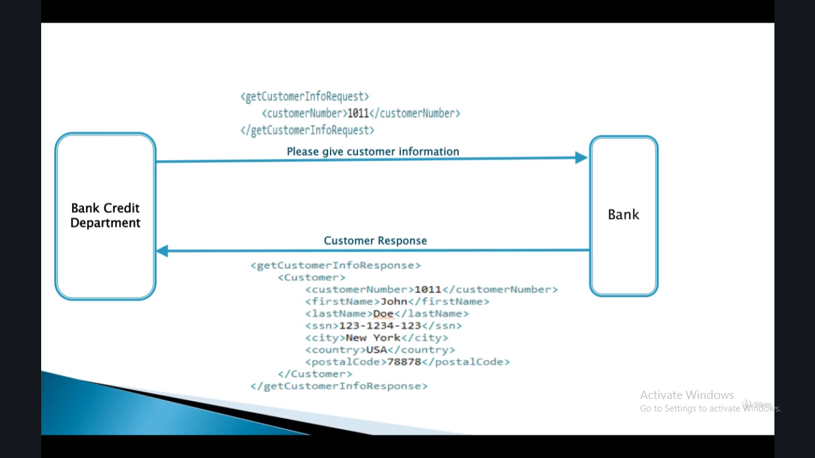

* This is how two applications communicate with each other with xml messages.
* Webservice is the best approach to communicate between two systems.

